The Rights and Limitations of Students & Teachers

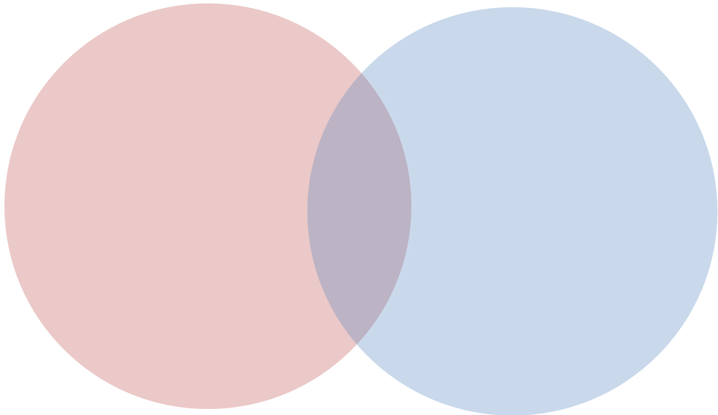
Students’ Limitations
Teachers’ Limitations
Teachers’ Rights
Students’ Rights

